

|  |  |  |  |  |
| --- | --- | --- | --- | --- |
| 84 Gregory St. Rochester, NY |  | p. 518-322-9799 |  | rbucinell@gmail.com  www.cs.rit.edu/~rmb1201/ |

[NACKA Kickball Manager]

NACKA Kickball Mobile Application

Table of Contents

1. Application Summary 2

Overview

Objectives

Technologies

1. Design & Workflow 2

Staged Implmentation

Theme

Screen Concepts

Navigation

1. Development 5

Blackbox 3rd Party Approach

Feature Dealines

Pricing

1. Expansion [Not Updated] 6

Tiered Feature Plans [Not updated]

Expanded Customer Requiremnts[Not updated]

# Application Summary

## Overview

The NACKA Kickball Manager (A.K.A. NACKA app) is designed to be a complement to its parent site [http://www.nackakickball.com](http://www.nackakickball.com/). It will enable captains and players to access the most relevant data from the website as possible to keep everyone informed. The app will accomplish this by providing information about team schedules, field locations, and standings.

## Objectives

* To create a mobile friendly view of information available on the website
* Strip out excess information, only most pertinent data needs to be accessible
* Simple interface to clearly display data and navigate tool.
* Backend code flexible and dynamic as possible to enable tiered development goals

## Technologies

The NACKA app will be targeted for Android ( v4.2 Honeycomb or newer ) devices initially. This will enable rapid development in the Java programming language as well as cut back costs in development and deployment of the application. The app will extend to use GPS features to enable directions to venues as well.

# Design and Workflow

## Staged Implementation

In order to maintain substantial updates to the application with quick deployment time, this application will continue to add features after the initial release of the app. This will also allow the purchaser of the app to request new features as needed without a large initial upfront cost.

Sample Stages

* Stage 1: Team Schedules & Map
* Stage 2: Team standings, Expanded lookup, and field usage.
* Stage 3: Lineup Management
* Stage 4: Advertisements Push notifications of alerts

## Theme

The theme of the application will designed to complement and match that of the NACKA website. The color scheme present of red, greys, and black will be replicated in the application where applicable. Century Gothic text and resources such as site logos, banners, and icons will be used where applicable and allowed.

## Screen Concepts

The following are the initial screen concepts for the first stage of the application.

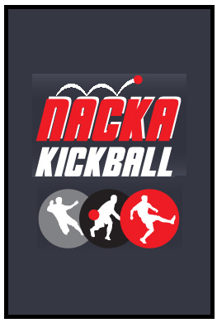Loading Screen:

* Utilizes color scheme and logos
* Will load data in background while providing pleasant graphic
* Display version number in corner

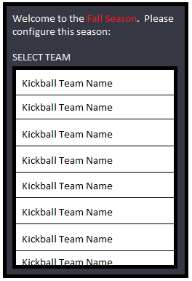First-time configuration page:

* Screen will be displayed when the user has not set (or recently cleared) their current team for the given season.
* Note the red text will be dynamic, the season will update when season changes
* Team lists will be parsed from [/scheduler/aplsteamlist.htm](http://www.nackakickball.com/scheduler/aplsteamlist.htm) webpage
* Dragging your finger up or down will scroll through the list
* Tapping on a team will set the team as your current team
* Large text and big elements will allow for easy user selection and readable text

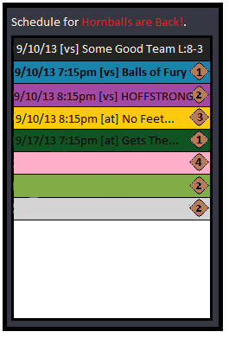Current Team’s Schedule:

* This will be the default screen after the first time configuration is set
* Text displays which team the schedule is for.
* List will display the matchups for the season
  + - * + Each list element will include date, time, vs/at, opponent name, field, and opponent color
      * The background of each list element will display the opponent’s tshirt color.
      * Games that have not been resolved will display the time and the field on which they will be playing
        + Clicking on the field icon will take users to the Field Map
      * Games that have been resulted will display the score of the game

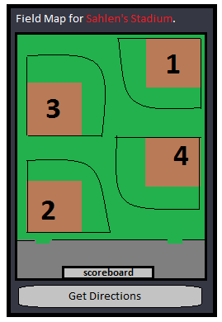Field Map:

* Map will display current venue’s layout
* Get directions to venue button will open the Mapping application to get directions to the venue.

## Navigation

Navigation through the app will be controlled by menus and action bars triggered by menu hardware keys. Stage 1 features will not need navigation tools aside from back action out of field map. There will be an action bar to jump to team configuration screen to change teams as needed.

# Development

## Blackbox 3rd Party Approach

Currently due to permissions and access limits of data, this application will gather data from a 3rd party perspective. The concept of a black box, is you cannot look into or access any of its internals, as such with the website there is not an avenue of accessing raw data or utilizing an API for the website. This means data will be gathered through parsing techniques. This will add to development time, reduce stability, and cause longer update periods.

## Feature Deadlines

Currently no deadlines have been formally set. Aim is to have beta version of application in test before the end of the season and a stable build by the winter season.

## http://www.ideatoappster.com/wp-content/uploads/2012/12/how-much-does-it-cost-to-build-an-app-455x1024.pngPricing

Given the lack of backend data access. There will be some initial work that will need to be put in parse the data. The first tier of features, the team schedule, map, as well as the initial development will run you $300. As future stages of the app are developed and discussed, new features will be negotiated

Google Play Appstore publishing costs, while optional are highly recommended. They will run a one-time fee of $25.

If you want a rough average look at what normal costs to develop an app though a development team or contract programmer, I have included this info graph to the right.

# Expansion

## Tiered Feature Plans

…Will be updated in the future

## Expanded Customer Requirements

…Will be updated in the future